Name : AKHIL C
Roll no : 24BAD007
EXPT NO:5 | DEVELOP INTERACTIVE DASHBOARDS FOR DYNAMIC DATA EXPLORATION USING TABLEAU AND POWERBI
DATE: 24.07.2026

PRE-LAB QUESTIONS

- What is dynamic data exploration in BI tools, and why is it important?
Dynamic data exploration allows users to interact with data by applying filters, slicers, and drill-down options. It helps users quickly analyze data, discover trends, and make better business decisions.

- What are slicers and filters, and how do they enhance dashboard interactivity?
Slicers and filters allow users to display only the required data based on selected conditions. They make dashboards interactive by enabling users to view and compare specific information easily.

- How do Tableau and Power BI support drill-down and drill-through features?
Tableau and Power BI allow users to drill down from summary data to detailed data using hierarchies. Drill-through lets users navigate to another report page for more detailed analysis of a selected item.

- What is the role of parameters in creating interactive dashboards?
Parameters allow users to change values dynamically, such as selecting a metric or adjusting calculations. They make dashboards more flexible and interactive.

- Name some advanced interactivity features in Tableau and Power BI.
Some advanced interactivity features include:
- Drill-down and Drill-through
- Parameters
- Slicers and Filters
- Tooltips
- Actions (Filter, Highlight, URL)
- Bookmarks (Power BI)
- Dynamic Titles and KPI Selection

IN-LAB EXERCISE:
OBJECTIVE:
To design and develop interactive dashboards in Tableau and Power BI for dynamic data exploration, enabling users to analyze, filter, and drill down into data for deeper insights.
PROCEDURE:
- Data Collection:
    - Import datasets from sources such as Excel, CSV, SQL Server, or online APIs.
    - Dataset: Retail Sales Dataset with fields such as Order Date, Region, Product Category, Sales, Profit, Quantity.
- Data Preparation and Transformation:
    - Ensure proper date formats for time-based analysis. o Handle missing or incorrect values.
    - Create calculated fields (e.g., Profit Margin %, Sales Growth %, Year-to-Date Sales).
- Data Aggregation and Hierarchies:
    - Create hierarchies (e.g., Year → Quarter → Month → Day).
    - Aggregate data by region, product category, or customer segment.
- Designing Interactive Elements:
    - Filters & Slicers: Allow filtering by product category, date range, or region. o Parameters: Let users switch between KPIs (e.g., Sales vs. Profit). o Drill-down: Enable users to explore data from summary to detail.
    - Tooltips: Add contextual details when hovering over data points.
- Dashboard Development:
    - Tableau: Use interactive filters, parameter controls, and highlight actions.
    - Power BI: Use slicers, bookmarks, and drill-through pages.
    - Add KPI cards for key metrics like Total Sales, Total Profit, Top Selling Product. o Use maps for regional sales analysis, line charts for trends, and bar charts for category comparisons.
- Testing Interactivity:
    - Ensure slicers and filters update all relevant visuals dynamically.
    - Test drill-down and drill-through functionality for accuracy.
- Publishing and Sharing:
    - Tableau: Publish on Tableau Public or Tableau Server.
    - Power BI: Publish to Power BI Service and share via workspace access or public link.

Screenshots of Tableau :
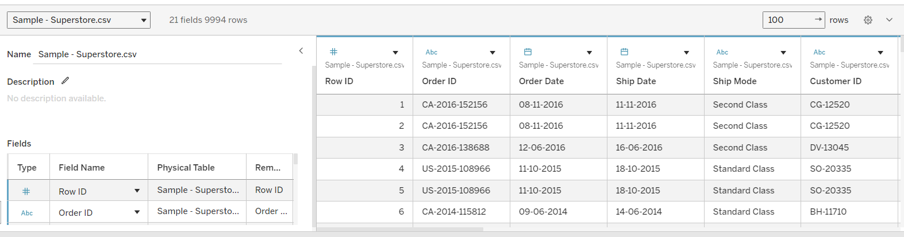
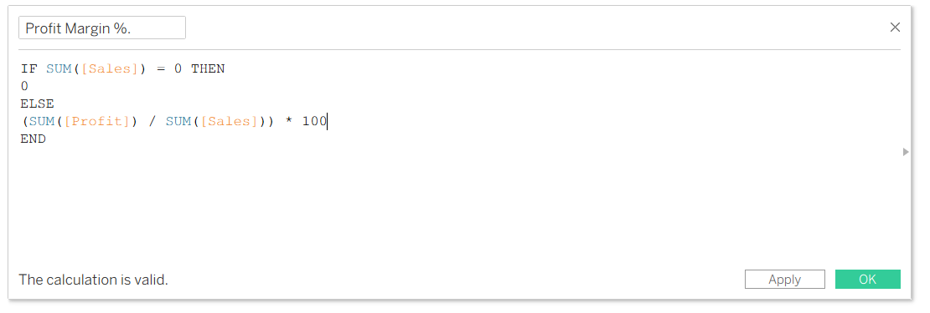
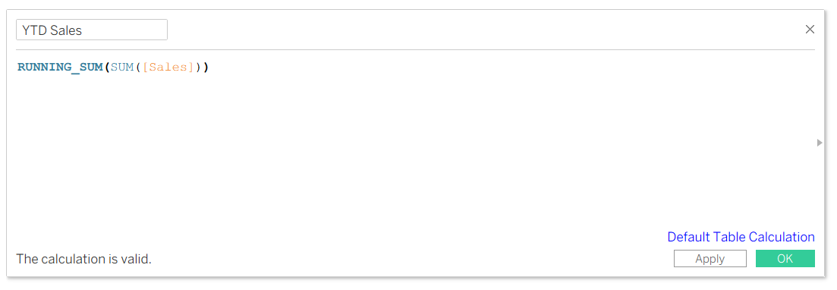
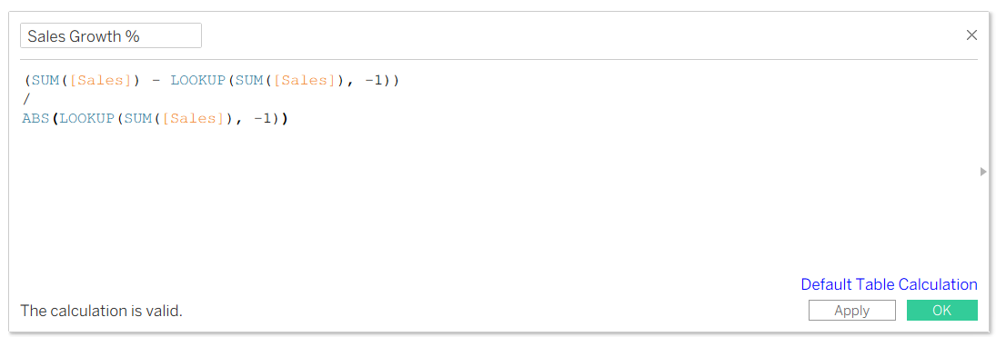
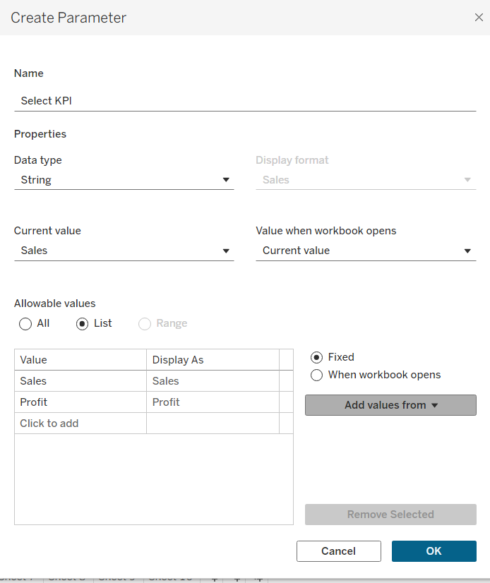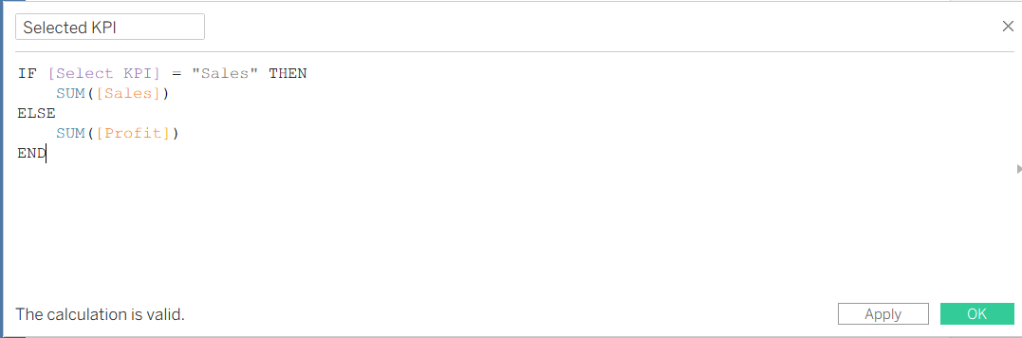

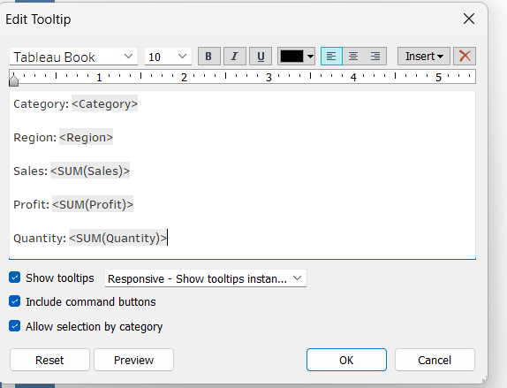

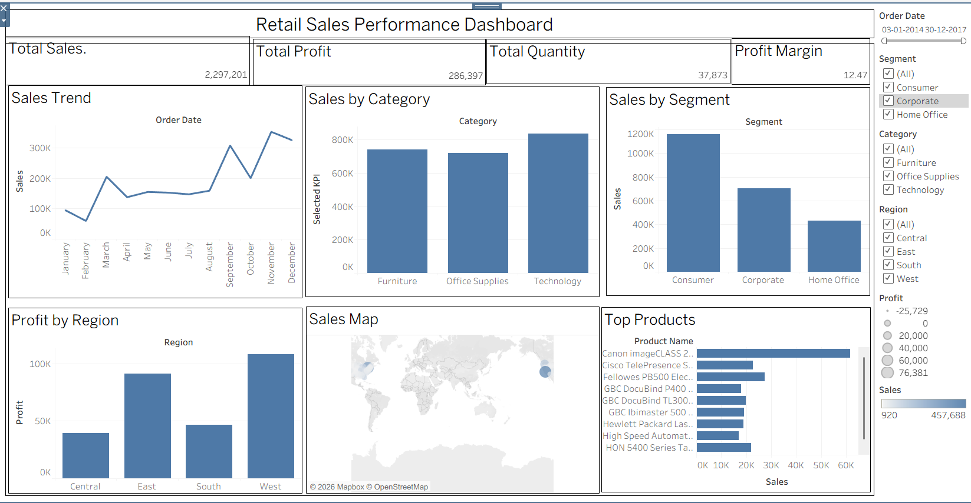

Screenshots of PowerBI :
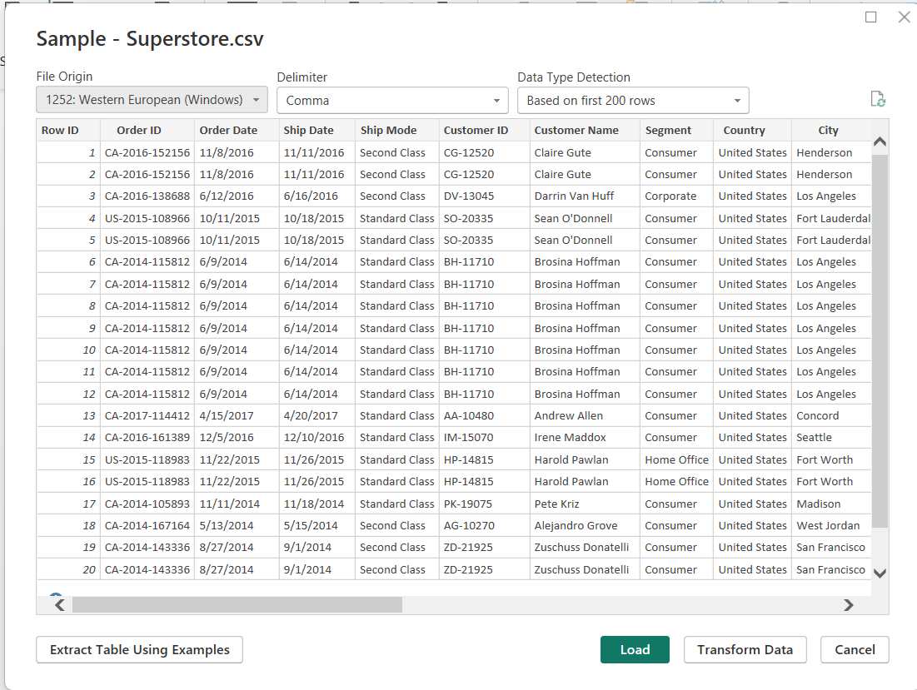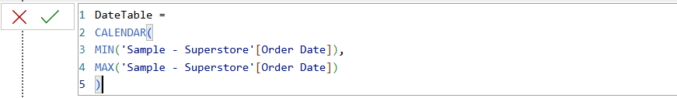
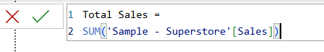
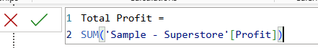
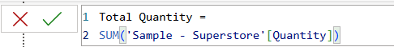
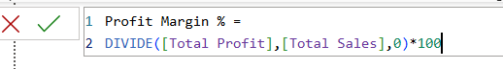
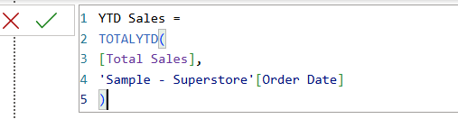
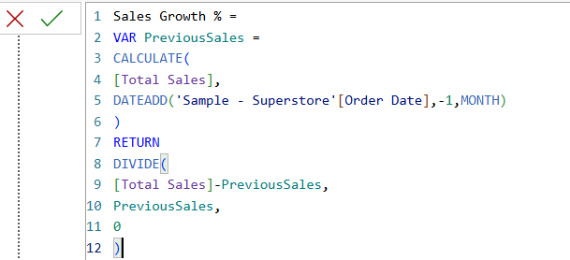
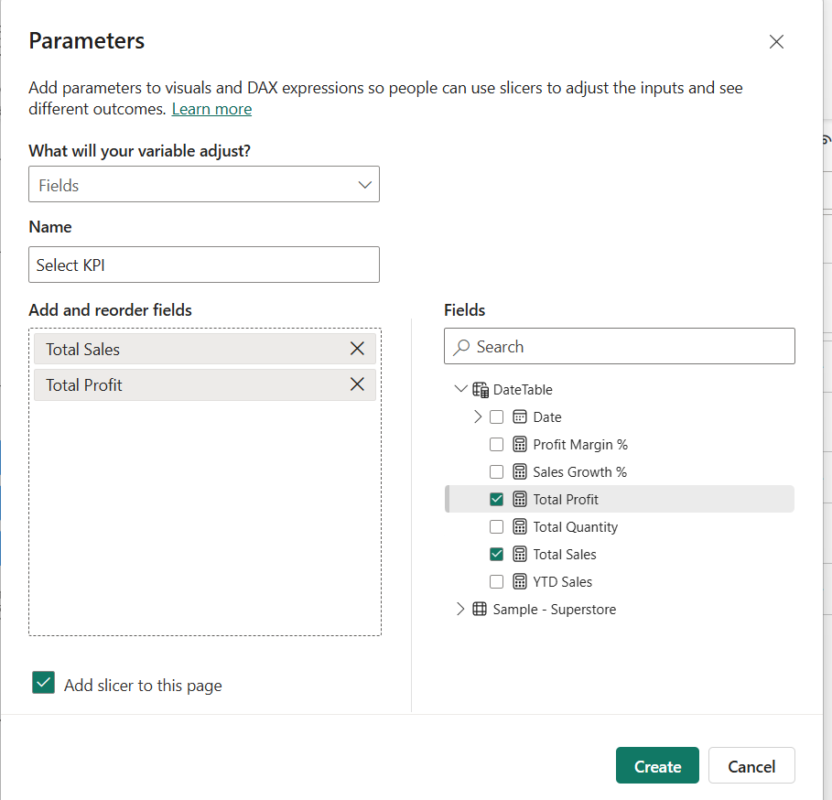
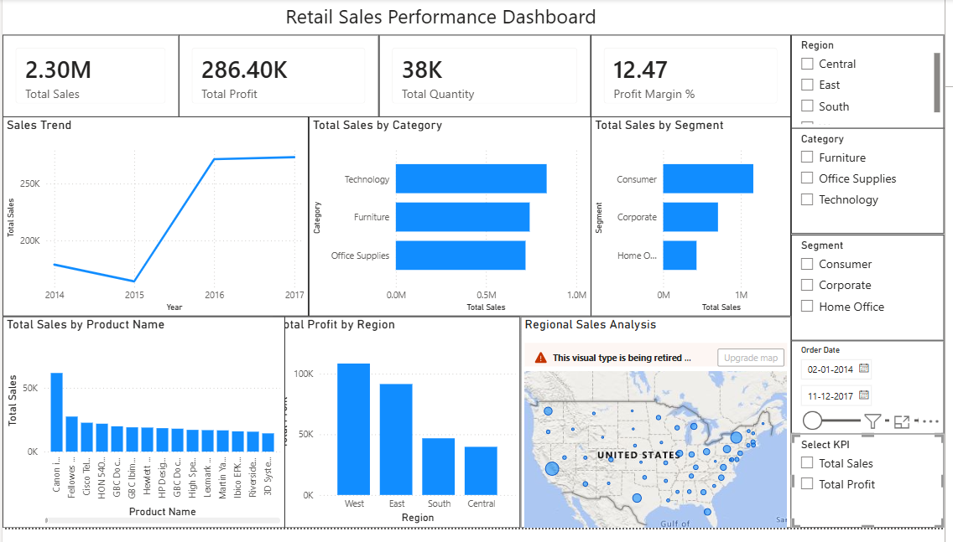

Experiment Dataset:
Retail Sales Dataset
Fields Used:
  - Order Date – Date of the order
  - Region – Sales region
  - Product Category – Category of product sold
  - Sales – Sales revenue
  - Profit – Net profit from the order
  - Quantity – Units sold

POST-LAB QUESTIONS
- How did interactivity improve the analysis experience in your dashboard?
Interactivity allowed users to filter data, explore different views, and analyze trends easily. It made the dashboard more user-friendly and helped in gaining deeper insights quickly.

- Which interactive feature (filters, drill-down, parameters, etc.) was most useful and why?

The drill-down feature was the most useful because it allowed analysis from Year → Quarter → Month → Day, providing detailed insights without creating multiple charts.

- What challenges did you face while implementing drill-down or dynamic filters?
The main challenge was ensuring that filters and drill-down actions worked correctly across all visuals. This was resolved by properly configuring interactions and hierarchies.

- How do tooltips contribute to better dashboard storytelling?
Tooltips provide additional information when users hover over a data point, making the dashboard more informative without overcrowding the visuals.

- What additional features would you add to make the dashboard more insightful?
I would add forecasting, sales target comparison, customer segmentation, and advanced KPI indicators to provide deeper business insights and improve decision-making.

RESULT:

The retail sales dataset was successfully transformed, aggregated, and visualized into interactive dashboards in Tableau and Power BI. Filters, slicers, drill-downs, and parameters enabled dynamic exploration of sales and profit trends by region, product category, and time period. The resulting dashboards allowed for quick insights and deeper analysis, enhancing decision-making capabilities.

ASSESSMENT

Description |  | Max Marks | Marks Awarded
Pre Lab Exercise |  | 5
In Lab Exercise |  | 10
Post Lab Exercise |  | 5
Viva |  | 10
 | Total | 30
 | Faculty Signature

